**PCB Design**

Firstly, schematic design of the Altium is made. In order to solder components easily minimum component size is determined as 1206.

Figure 1: Altium Schematic

After the circuit schematic was created in Altium, the printed circuit board was designed. Since DC-DC converters have fast current and voltage transitions, these converters can cause problems in terms of electromagnetic emission. Therefore, attention should be paid to the PCB design, where the schematic design of flyback converters should be good. DC-DC converters are generally recommended to have 2 or 4 layers. Since the 4-layer structure is made for products with very high electromagnetic compatibility and heating problems, it was thought that only 2-layer structure would be sufficient for the application of flyback converter. IPC-2221B 6.2 sections were used to determine the road widths.

Figure 2: Power Path Road Width

As it can be seen from the above figure power path is calculated with the safety factor. Roads are designed to with stand 7.5 A.

Another thing to consider is the parasitic inductance value. Parasitic inductance can be increased or decreased depending on the path followed. The parasitic inductance value can cause many problems at high frequencies, the main ones being as follows:

* Increases EMC problems due to radiated electromagnetic field.
* It reduces the filtering efficiency of the capacitor.
* It creates high voltage transients during commutations.

IPC-2221B 6.2 sections were used to determine the distance of the gaps called clearance.

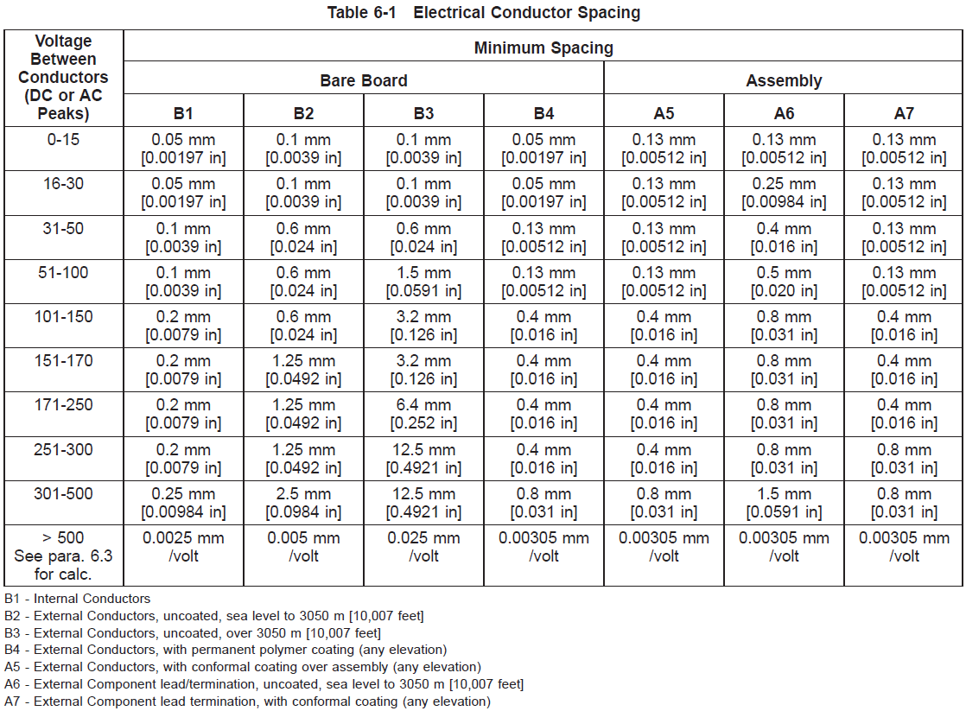

Figure 3: Clearance Table

The table about the distance that the vias should be with each other is given. This table was also used during the PCB design.

In order to increase electromagnetic compatibility, vertical turns were not preferred during PCB drawing. Instead, the path was lengthened, and the angles were reduced.

Figure 4: Path Shape Used in PCB Design

Figure 5: PCB Layout

Figure 6: Altium 3D PCB

**Heatsink**

Lastly required heatsink value is calculated.

Firstly, the total losses in the MOSFET are calculated for the cooler selection.

The Mosfet losses are calculated at the simulation report.

$P_{M}=P_{switching}+P_{cond}=1.334 W$

Afterwards, the required thermal resistance of the heatsink was calculated.

The formula for calculating this value is given below.

$T_{j}=\left(P_{max}×(R_{θjc}+R_{θcs}+R_{θsa})\right)+T_{a}$

Where;

$T_{j}$: MOSFET junction temperature

$P_{max}$: Maximum MOSFET loss value

$R_{θjc}$: Thermal resistance value from junction to case

$R_{θcs}$: Thermal resistance value from case to heatsink

$R_{θsa}$: Thermal resistance value from sink to ambient

$T_{a}$: Ambient temperature [2]

It is thought that the ambient temperature will not exceed 50℃. The thermal resistance values ​​are taken from the data sheet of the MOSFET, and it is written in the data sheet that the junction temperature should not exceed 175℃. If the values ​​are put in the equation;

$$175℃=\left(1.334×(0.5+2.4+R_{θsa})\right)+50℃$$

$$R_{θsa }≤80.43 ℃/W$$

**References**

1.*LITIX™ PCB design guidelines*. Infineon Technologies. (2021, August 2). https://www.infineon.com/dgdl/Infineon-Z8F80033952_LitixPower-ApplicationNotes-v01_00-EN.pdf?fileId=5546d46277921c320177a6104dfb2ad5.

2. (2002),*How to Select the Right CoolMOS and its Power Handling Capability,*(Application Note, V1.2,), Infineon Technologies